Installing Avast anti-virus (free version)

1. Log in to your Windows 10 device
2. Click the **Start** (⊞) icon in the bottom left corner
3. Type “Store” to bring up the Microsoft Store:

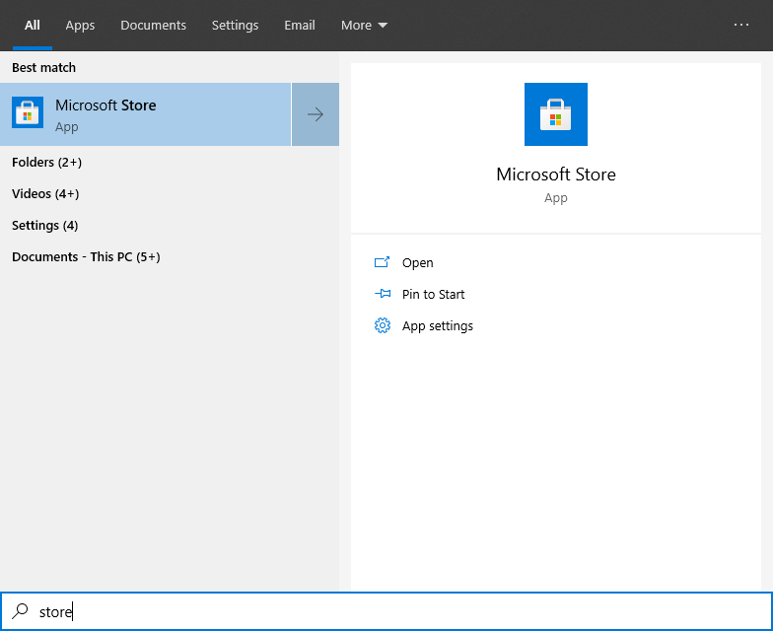

1. Open the Microsoft Store
2. In the top right corner click the search button and type “Avast”

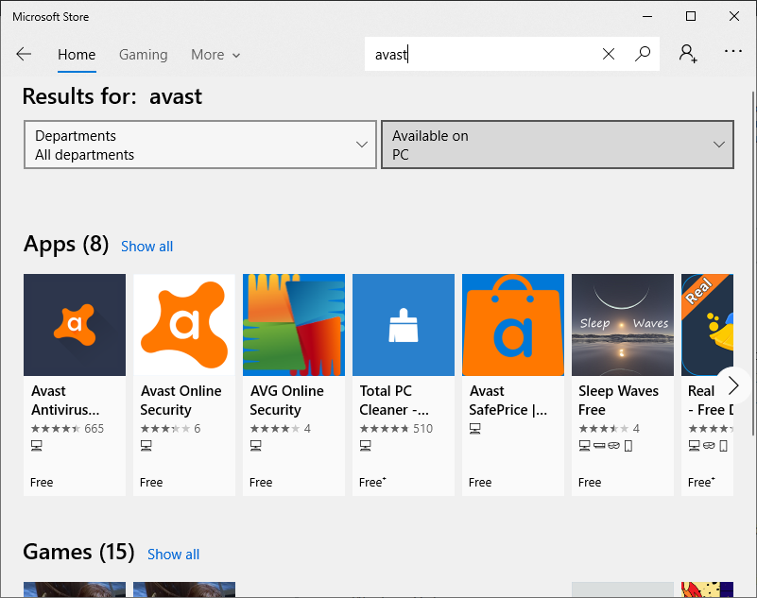

1. Click on the “Avast antivirus” icon:



1. On the following screen click the “Get” button

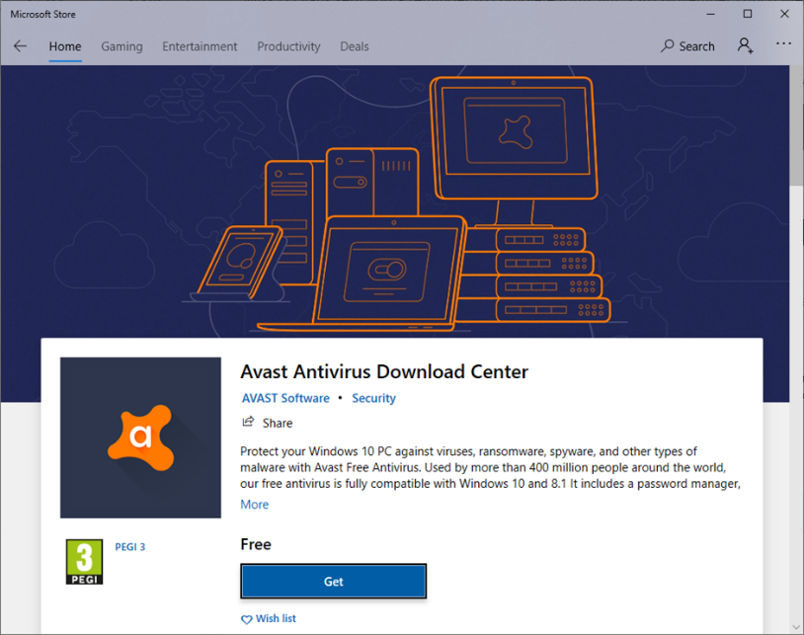

1. Click the Install / Launch button (this may take a few minutes to load once the file has downloaded)

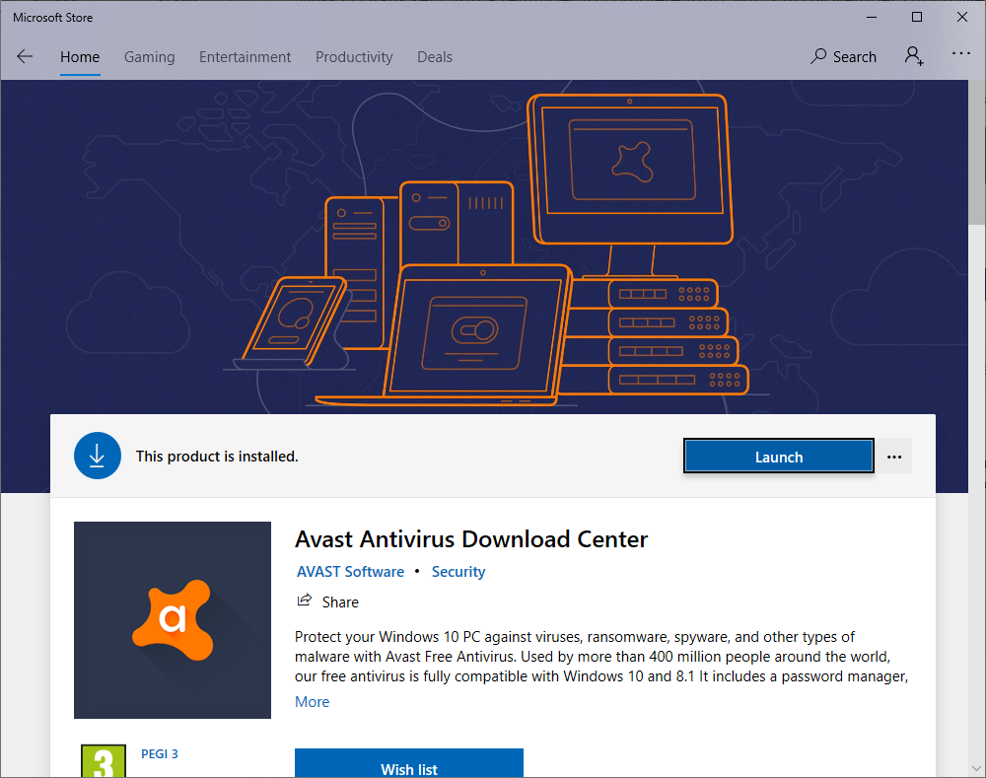

1. On the following screen click the “Free Antivirus” option:

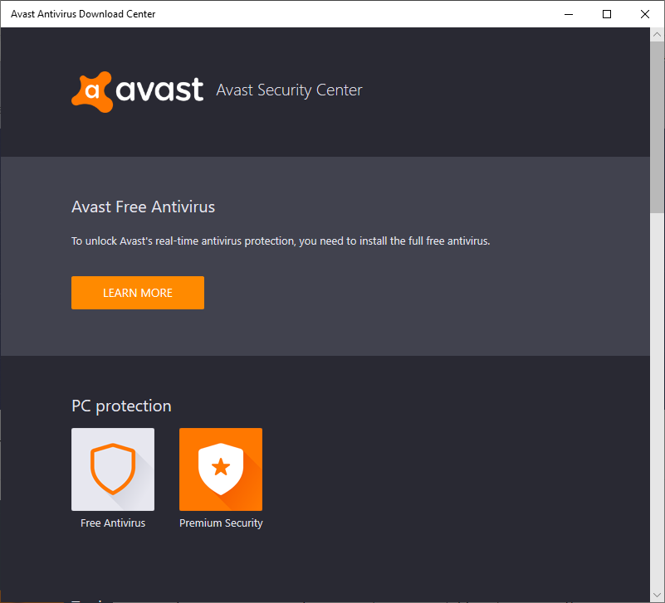

1. This will open a webpage where you can click the “Free download” button in the middle:

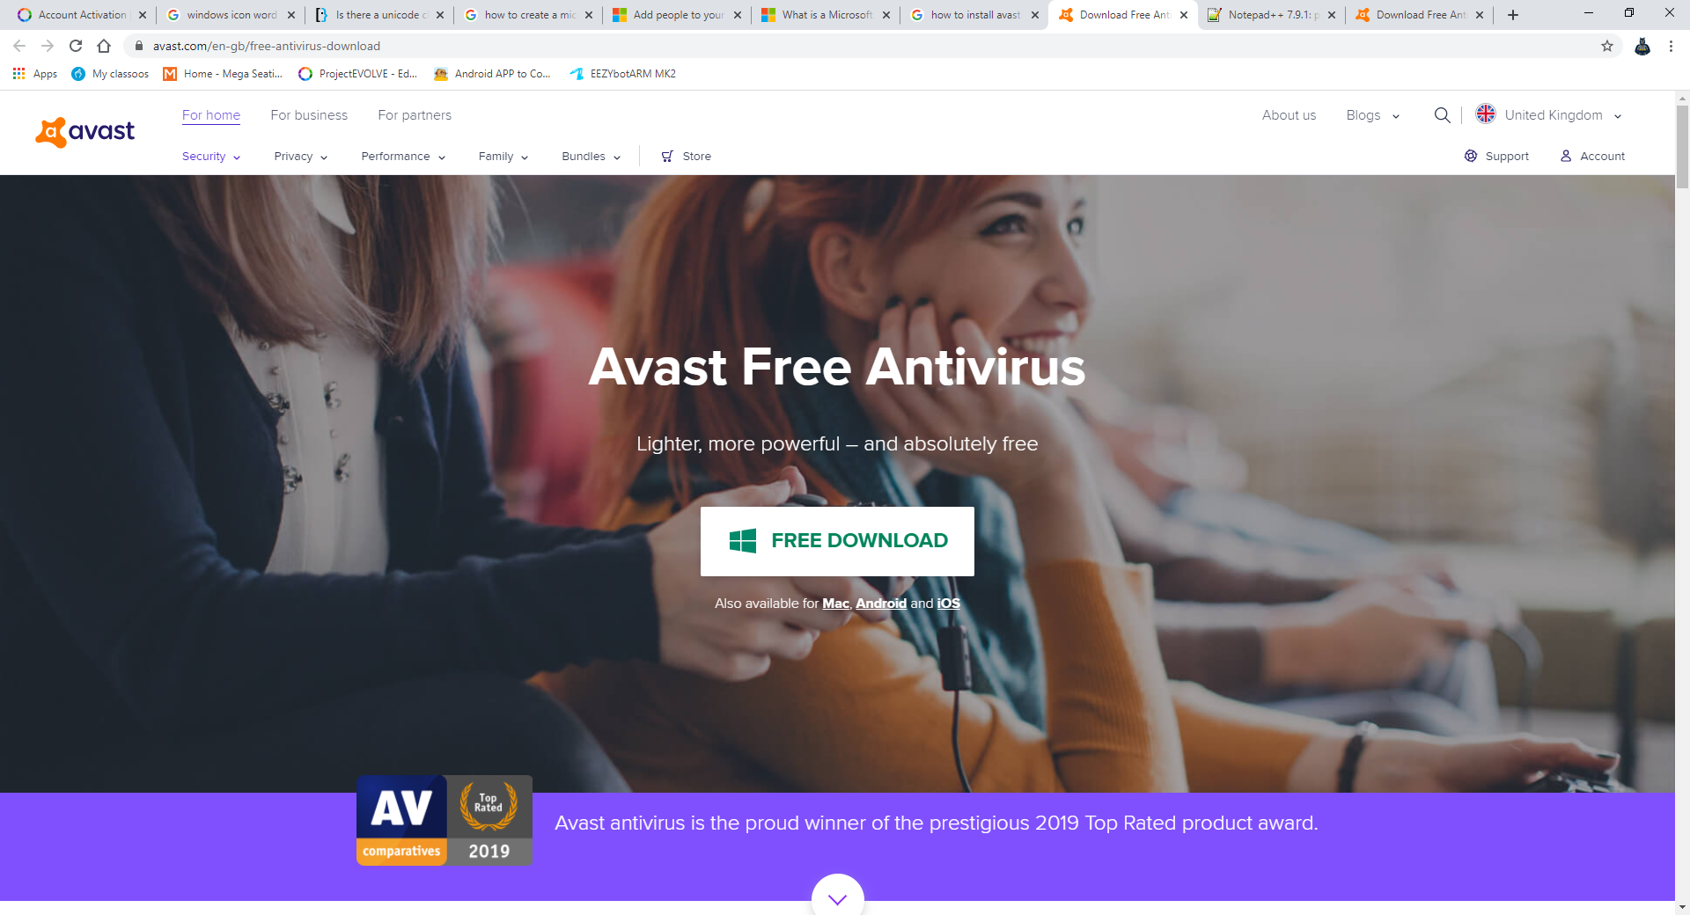

1. This will download a file – once it has downloaded run the file and follow the instruction prompts.

⚠ Note: You may receive a message from Windows 10 during the install explaining the built in security features – this is normal and will provide adequate protection.