Installing Office365 at home

The GDST has an agreement with Microsoft which allows all **current** staff and students to install Office 365 ProPlus (a full version of the Microsoft Office suite) for free on**up to 5**of your own devices. This includes phones, tablets, Macs and Windows PCs.

On a Computer...

* Using the computer that you intend to install O365 to, go to [https://www.office.com/](https://www.office365.com/) and sign in using your student email address and school password. (This should be written in your planners).
* Click on Install Office button (shown below).

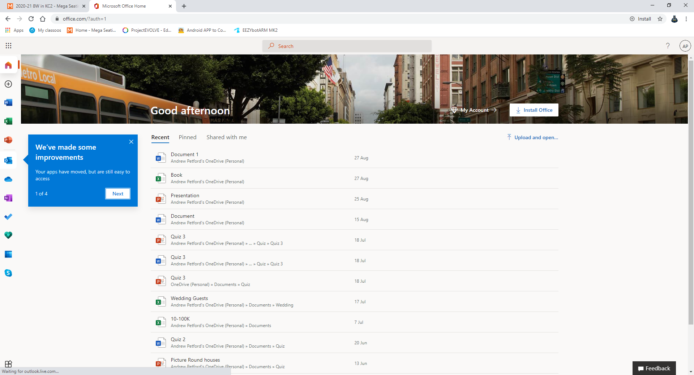

* Follow the on-screen prompts to install Office.

On a mobile device...

* Please visit your phone’s app store and install the Office Apps.
* Once installed sign into them with your school email address.

This subscription will remain active as long as you are with the school. More details can be found here: <https://products.office.com/en-us/business/office-365-proplus-business-software>