Setting up a Microsoft Family Group
A family group helps families stay connected and keeps kids safer on Windows 10, Xbox devices, and Android devices running Microsoft Family Safety. It's free, and it's one of the many benefits of having a Microsoft account. With the settings on family.microsoft.com, you can get reports on a child's activity, set screen time limits, check on a child's location, limit which websites and games they can access, and require your approval to purchase from the Microsoft Store.
⚠ Do you have a Microsoft Account?
You will need to have a Microsoft Account in order to create a “Family Group” – this allows you to be the parent and assign roles to your child.
To create an account:
- Go to https://family.microsoft.com/
- Click “Create a Family Group”
- Click the “Create one!” button
- Follow the prompts to set up a Microsoft Account – you can use an existing email address if you have one.
If you already have an account:
- Go to https://family.microsoft.com/
- Click “Create a Family Group”
- Enter your Microsoft account email and password

⚠ Does your child have a Microsoft Account?
You will need to have set your child up with an account on Windows 10. If you haven’t done this:
- Go to http://account.microsoft.com
- Click the “Create a Microsoft Account”
- Follow the prompts to set up a Microsoft Account.
If they have an existing email address (not their school email) they can use this to sign up for a Microsoft account.
Every student will need a personal (not school) Microsoft Account so that they can:
- access the device outside of school term time
- be added to a Microsoft Family Group
- use the device after they have finished their studies at the high school

To create a family group:
- Go to family.microsoft.com.
- Select Create a family group and follow the on screen prompts to log in and add your child.
- Once you have added your child to your family group you can click on them on your family homepage to edit their individual settings:
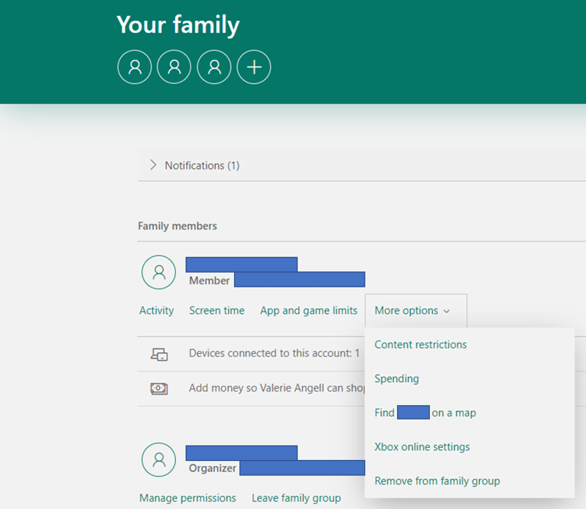

- To set up family settings such as:
  - Screen Time Schedules
  - Content Filters
  - Spending Restrictions (if you have added a Credit Card to your account)
  - Location Reporting
Go to: https://tinyurl.com/SHRFamilySafety

